**P510/1**

**PHYSICS**

**Paper 1**

**March, 2017**

2½ hours

**Uganda Advanced Certificate of Education**

**S.6 RESOURCE EXAMINATION 2017**

**PHYSICS**

**Paper 1**

**2 hours 30 minutes**

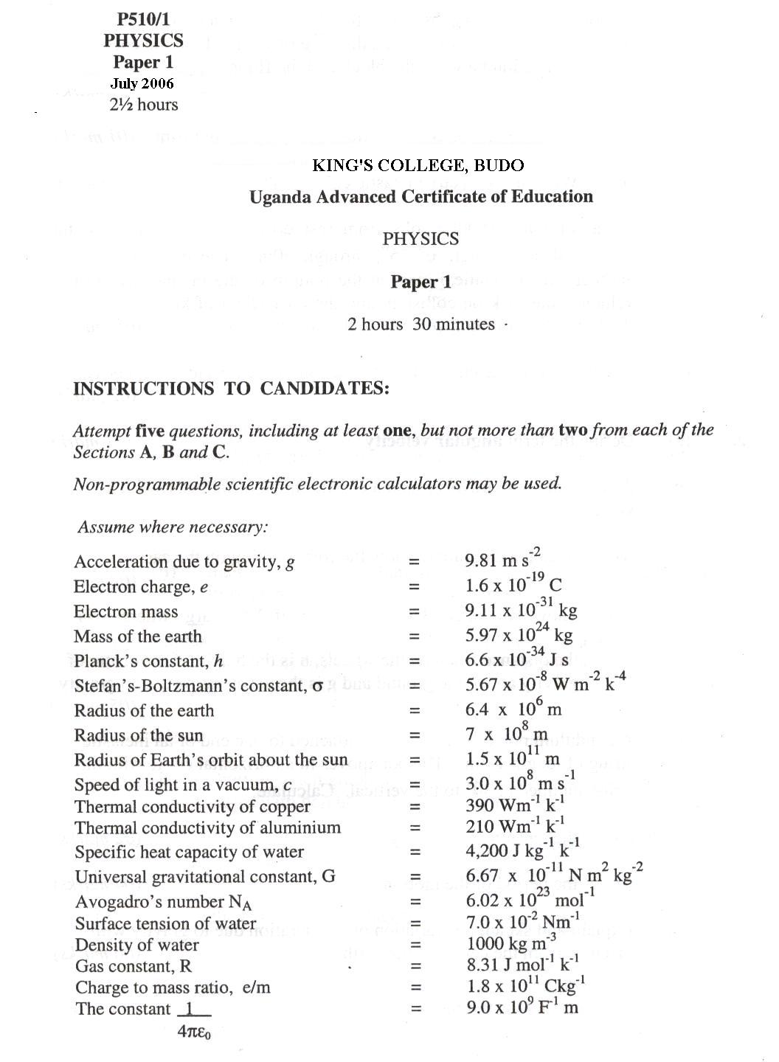

1. (a) (i) What is meant by ***uniform velocity***? (1mk)

(ii) Sketch the displacement-time graph for a uniformly accelerated body (1mk)

(iii) What is a projectile? (1mk)

(iv) Derive the equation of uniformly accelerated motion that relates displacement, time, velocity and acceleration. (3mks)

(b) A projectile is fired horizontally from the top of a cliff 200 m high. The projectile lands 1000 m from the bottom of the cliff.

Find the:

(i) initial speed of the projectile (4mks)

(ii) velocity of the projectile just before it hits the ground. (6mks)

(c) Describe an experiment to locate the centre of gravity of a plane sheet of material having an irregular shape (4mks)

2. (a) (i) State the laws of solid friction. (3mks)

(ii) Describe an experiment to determine the coefficient of static friction between a block and a given surface. (4mks)

(b) The diagram below shows a mass m fixed to one end of a horizontal spring and resting on a very rough horizontal surface. The other end of the spring is fixed to a point in a wall

P

m

m is now pulled to a point P and then released.

(i) Explain the behaviour of m when it is released. (2mks)

(ii) State the energy changes that occur in the system from the time m is released. (2mks)

(c) A rope BC is fixed between end B of a uniform rod AB and a point C in a rough vertical wall. The rod rests in limiting equilibrium with its end A in contact with the wall, where A is vertically below C and it makes an angle of 60o with the wall

B

C

A

60o

30o

If the rope makes an angle of 30o with the wall and the weight of the rod is 20 N, find:

(i) the tension in the rope (4mks)

(ii) the coefficient of friction between the rod and the wall (4mks)

3. (a) (i) Distinguish between ***tangential velocity*** and ***angular velocity*** of a particle describing a circle. (3mks)

(ii) Derive an expression for the tangential velocity of a particle describing a circle of radius r at an angular velocity ***ω*** . (3mks)

(iii) Each of the figures below shows part of the path taken by

1. a particle describing a circle uniformly and

2. a projectile

1. Describing a circle 2. Projectile

Distinguish between the two kinds of motion (2mks)

(b) A particle of mass M1 collides with another stationary particle of mass M2. If the coefficient of restitution, e = M1/M2, show that the particles simply exchange their momenta on impact. (4mks)

(c) A block of mass 0.5 kg is hung on an inelastic string of length 0.8 m. The block is now hit directly by a bullet of mass 30 g moving at a velocity of 150 ms-1.

Determine

(i) the minimum tension experienced by the string during the subsequent motion. (5mks)

(ii) the tension in the string when the string becomes horizontal (3mks)

4. (a) (i) Define ***specific latent heat of vaporisation***. (1mk)

(ii) With the aid of a well labelled diagram, describe an electrical method of determining the specific latent heat of vaporisation of water. (7mks)

(b) A 500 W electric heater is immersed in 4 kg of water at 25oC contained in a copper vessel of mass 0.5 kg. Neglecting any loss of heat to the surroundings and the heat capacity of the heater, find:

(i) how long it will take to heat the water to its boiling point of 100oC (4mks)

(ii) how long it will take to boil off all the water. (3mks)

(iii) how much it will cost to achieve b(ii) above if 1 kWh is Sh 450.00? (2mks)

(c) At low temperature, the molar heat capacity of copper varies with temperature T as βT2, where β = 4.6 x 10-4 J mol-1 K-1. How much heat is required to raise the temperature of 2 moles of copper from 0 kelvin to 2 kelvin. (3mks)

5. (a) (i) Mention the steps involved in establishing a temperature scale. (2)

(ii) State the advantages and disadvantages a thermocouple thermometer has over a platinum resistance one. (3)

(iii) Describe how the temperature of a liquid bath may be measured using a platinum resistance thermometer. (4mks)

(b) (i) The resistance Rθ of platinum varies with temperature θoC as measured by a constant-volume gas thermometer according to the equation

Rθ = Ro(1 + 8000θ  θ2)

where  is a constant. Calculate the temperature on the platinum scale corresponding to 200oC on this gas scale. (4mks)

(ii) Explain why the two thermometers do not agree exactly. (1mk)

(c) In a continuous flow experiment on a liquid of specific heat capacity 4200 Jkg-1K-1 the following results were obtained:

|  |  |  |
| --- | --- | --- |
| Ammeter reading/A | Voltmeter reading/V | Mass of liquid collected per min/g |
| 2.00 | 25.2 | 75.0 |
| 2.52 | 30.0 | 115.9 |

If the inflow temperature was 15oC find

(i) the outflow temperature (4mks)

(ii) the rate of heat loss (2mks)

6. (a) (i) State Wien’s and Stefan’s laws of black body radiation. (2mks)

(ii) Explain how a perfectly black body can be approximated in reality? (4mks)

(iii) Describe an experiment to compare surfaces as absorbers of radiation. (4mks)

(b) The energy intensity received by a spherical planet from a star is 1.4 x 103 W m-2. The star is of radius 7.0 x 105 km and is 1.4 x 108 km from the planet from the planet.

(i) Calculate the surface temperature of the star. (4mks)

(ii) State any assumptions you have made in (b)(i) above. (1mk)

(c) (i) What is ***convection***? (1mk)

(ii) Explain the occurance of land and sea breezes. (4mks)